Integrated Patient Care Management Platform
A Project Based Learning Report Submitted in partial fulfilment of the requirements for the award of the degree
of

Bachelor of Technology
in The Department of CSE
24AD2103A-DATABASE MANAGEMENT SYSTEMS
Submitted by
2410030076 – Kodali Naga Sreeja
2410030228 – Bijju Adithi Yadav
2410030229 – Likitha Thumma
2410030232 – Esha Manogna
2410030430 – Malreddy Manogna

Under the guidance of
Dr. N. Rama Rao
Associate Professor



Department of Electronics and Communication Engineering
Koneru Lakshmaiah Education Foundation, Aziz Nagar
Aziz Nagar – 500075
FEB - 2025.

Problem Statement
Manual hospital processes like patient registration, appointment scheduling, and record management are slow, error-prone, and inefficient. To improve accuracy and efficiency, there is a need for an automated system that can manage hospital operations effectively.
Abstract
The Hospital Patient Management System (HPMS) is designed to provide an efficient, reliable, and automated solution for managing hospital operations. In most hospitals, essential activities such as patient registration, appointment scheduling, medical record maintenance, billing, and staff coordination are carried out manually, which often results in errors, data redundancy, delays, and difficulty in retrieving information. To address these issues, HPMS makes use of a structured database management system that centralizes hospital data and allows quick access to patient information, doctor availability, treatment histories, and billing details. The system reduces paperwork, eliminates duplication of records, and ensures consistency by applying normalization techniques. By integrating multiple functional modules into a single platform, it improves coordination between doctors, staff, and patients while enhancing the overall quality of healthcare services. Furthermore, it provides secure storage and retrieval of sensitive medical data, ensuring privacy and confidentiality. This project not only demonstrates how database concepts such as schema design, entity-relationship modelling, and SQL queries can be applied in real-world healthcare environments but also highlights the importance of technology in improving efficiency, accuracy, and patient satisfaction within hospitals.
Introduction
The Hospital Patient Management System (HPMS) is a database management system developed to simplify and organize hospital operations. Hospitals deal with large volumes of data daily, including patient details, doctor information, appointments, treatments, billing, and staff records. Managing all this information manually is time-consuming, error-prone, and inefficient. A well-structured digital system helps overcome these challenges by providing quick access, data security, and efficient storage of medical information.
The main purpose of HPMS is to maintain accurate patient records and ensure that hospital staff can access and update data when needed. It allows patients to be registered easily, doctors to be allocated based on specialization, appointments to be scheduled without confusion, and billing to be generated automatically. This reduces paperwork, avoids duplication of records, and improves the overall workflow of the hospital.
From a database perspective, HPMS focuses on storing information in a relational model with tables for patients, doctors, staff, wards, and billing. Relationships between these entities are carefully designed to avoid redundancy and ensure data consistency. Queries can be used to retrieve useful reports, such as patient history, doctor schedules, and hospital occupancy.

Literature Review

Paper 1: An LSTM Neural Network Approach to Resource Allocation in Hospital Management Systems.
Ashish K Saxena, Rohit R. Dixit, Attia Aman-Ullah.
https://moodle.net/.pkg/@moodlenet/ed-resource/dl/ed-resource/3eyM1Ehp/967_An_LSTM_Neural_Network_Approach_to_Resource_Allocation_in_Hospital_Management_Systems.pdf

-> Hospital Management Systems are important for coordinating clinical, operational, and administrative activities in hospitals.
-> A major challenge in HMS is efficient resource allocation (staff, equipment, and patient care).
-> This project uses a Long Short-Term Memory neural network, a type of deep learning model, to improve resource allocation.
-> The LSTM model learns from historical and real-time data to predict resource requirements accurately.
-> The study compares predictions with actual hospital data and shows high accuracy and reliability.
-> The model can act as a decision-support tool for hospital planning and management.
->Benefits include:
- Reducing patient waiting times
- Optimizing staff and equipment allocation
- Improving quality of patient care
-> The project shows how artificial intelligence and data analysis can be applied in healthcare management to make hospitals more flexible, efficient, and patient-focused.

Paper 2: SMART Hospital Management Systems Based on Internet of Things: Challenges, Intelligent Solutions and Functional Requirements.
Dalia Kamal Abd Alla Rizk , Hoda M. Hosny , Sayed ElHorbety , Abdel-Badeeh Salem.

https://ijicis.journals.ekb.eg/article_206332_4117dcd64abf79bf579bfc1d910b52bc.pdf

-> Internet of Things (IoT) connects physical objects through the internet, and it is rapidly being adopted across many sectors, including healthcare.
-> Hospitals need to shift from traditional documentation to SMART management systems for better efficiency and patient care.
-> IoT devices collect different types of patient data and transfer them to cloud computing for storage and analysis.
-> Benefits of IoT in healthcare include:
- Quick collection and transfer of patient data
- Real-time monitoring of patient health
- Support for activities like drug supervision and medical imaging
- Cost-saving and efficient healthcare services
-> Challenges of IoT in hospital data management:
- Security and privacy issues
- Device-to-device communication problems
- Reliable data collection and management
-> Accurate and timely information is crucial in healthcare — notifications at the right time can save patients’ lives.
-> Existing smart healthcare models are tailored to specific applications; there is no universal standard framework.
-> The proposed model in this research defines minimum functional and non-functional requirements for any SMART hospital system.
-> Critical cases are prioritized by sending alerts to caregivers for timely intervention.
-> Cloud computing is used for storing and managing collected healthcare data.
-> The study emphasizes time, security, accuracy, and punctuality as the most important requirements for healthcare data management.
-> A proposed IoT-based architecture is being developed to address these requirements and will be tested in real medical environments.

Paper 3: Recent Advancements in Emerging Technologies for Healthcare Management Systems: A Survey.
Sahalu Balarabe Junaid, Abdullahi Abubakar Imam, Abdullateef Oluwagbemiga Balogun, Liyanage Chandratilak De Silva, Yusuf Alhaji Surakat, Ganesh Kumar.

https://www.mdpi.com/2227-9032/10/10/1940

-> Recent advancements in IoT, AI, and Blockchain are significantly influencing the healthcare sector.
-> Smart wearable sensors, IoT, and AI are transforming healthcare from traditional systems to personalized healthcare management systems (HMS).
-> Challenges in implementing these technologies include:
- High cost and lack of accurate smart medical sensors
- Unstandardized IoT architectures
- Device heterogeneity
- Multidimensional data
- High demand for system interoperability
-> The paper surveys the application of smart sensors, IoT, AI, and Blockchain in HMS to evaluate progress and challenges.
-> A unique taxonomy is proposed, dividing the process into four major areas:
- Sensors
- IoT
- AI
- Blockchain
-> Sensors and IoT enable data collection and transmission, improving diagnosis, supervision, and treatment in HMS.
-> Critical issues with sensors and IoT include:
- User acceptance
- Data synchronization
- Scalability
- Interoperability
- Data security and privacy
-> AI and Blockchain contribute by:
- AI: providing data visualization, analysis, and decision-making capabilities
- Blockchain: enabling secure, decentralized health data storage with controlled access
-> Barriers to adoption include:
- AI: data quality, ethical concerns, privacy
- Blockchain: high implementation cost, user acceptance, regulatory policies
-> The study presents a detailed review and innovative classification of research based on the full Sensor-IoT-AI-Blockchain framework in healthcare.
-> The work aims to guide both academic and industrial researchers on the technical aspects and potential research opportunities in HMS.
-> The survey highlights open research challenges and provides future research directions for enhancing HMS with these emerging technologies.

Workflow

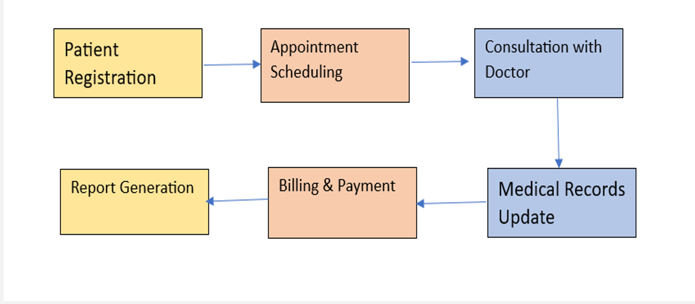
1. Patient Registration
- This is the first step where patient details are collected, such as name, age, gender, contact info, medical history, and ID details.
- It creates a unique patient record in the hospital database for future reference.
2. Appointment Scheduling
- After registration, patients can schedule an appointment with a doctor.
- The system helps in allocating time slots efficiently and reduces waiting times.
- Patients can also reschedule or cancel appointments if needed.
3. Consultation with Doctor
- During this step, the patient meets the doctor either physically or virtually.
- The doctor checks the patient’s health condition, diagnoses the problem, and suggests treatment, tests, or prescriptions.
4. Medical Records Update
- All information from the consultation (diagnosis, lab results, prescriptions, treatment plans) is updated into the patient’s digital medical record.
- This ensures that every future visit has a complete health history of the patient.
5. Billing & Payment
- Once the consultation and medical updates are completed, billing is generated.
- This includes charges for consultation, lab tests, medicines, and other hospital services.
- Patients can pay through cash, card, or digital payment systems.
6. Report Generation
- Finally, reports such as medical history, lab results, discharge summary, and payment receipts are generated.
- These reports are stored in the system and can be accessed by both the patient and the hospital whenever needed

System Architecture

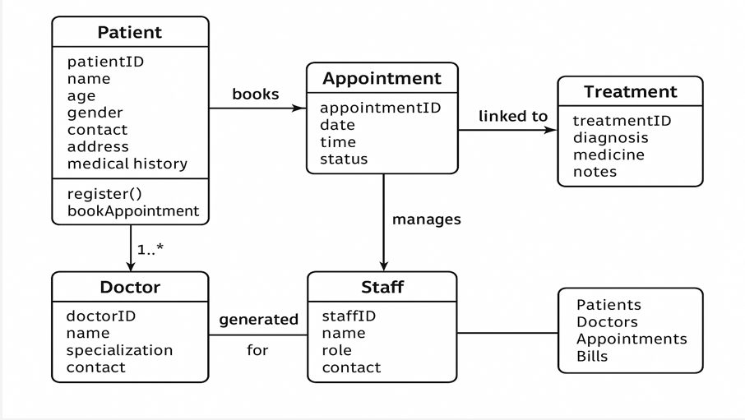
1] Patient Module
  - Stores patient details like ID, name, age, gender, contact, address, and medical history.
  - Patients can register themselves and book appointments.
  - Acts as the central entity in the system.
2] Doctor Module
  - Contains doctor details such as ID, name, specialization, and contact information.
  - Each doctor can have multiple patients assigned through appointments.
  - Responsible for consultation, diagnosis, and treatment.
3] Appointment Module
  - Connects patients with doctors by booking appointments.
  - Maintains details like appointment ID, date, time, and status.
  - Acts as a link between Patient, Doctor, and Treatment modules.
4] Treatment Module
  - Linked directly to Appointments.
  - Stores treatment details such as diagnosis, prescribed medicines, and notes.
  - Provides medical records that can be updated after every consultation.
5] Staff Module
  - Manages appointments and helps with administrative tasks.
  - Stores details such as staff ID, name, role, and contact.
  - Responsible for coordinating between patients, doctors, and billing.
6] Billing/Report Generation (Output)
  - Generated for patients, doctors, appointments, and bills.
  - Ensures that all interactions (consultations, treatments, payments) are documented.

ER Diagram

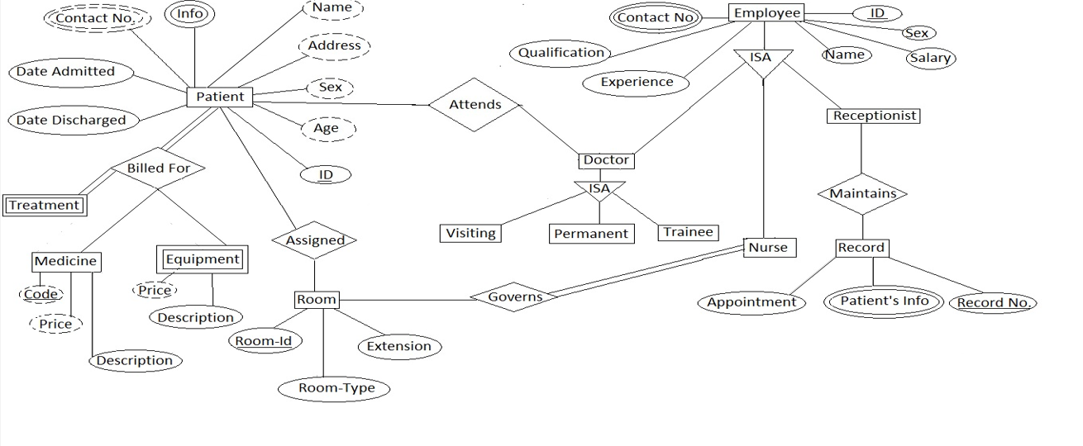
-> Patient Entity
- Attributes: Patient ID, Name, Age, Sex, Address, Contact Number, Date Admitted, Date Discharged.
- Patients are billed for Treatments, assigned Rooms, and attend consultations with Doctors.
-> Treatment Entity
- Attributes: Treatment ID, Description.
- Linked with Medicines (with Code, Price) and Equipment (with Price, Description).
- Represents the medical services provided to patients.
-> Room Entity
- Attributes: Room ID, Room Type, Extension.
- Patients are assigned rooms during admission.
- Rooms are governed by Nurses for monitoring and care.
-> Doctor Entity
- Attributes: Doctor ID, Name, Qualification, Experience.
- Specialization into Visiting, Permanent, and Trainee doctors (ISA relationship).
- Doctors attend patients and oversee their treatments.
-> Employee Entity
- Attributes: Employee ID, Name, Sex, Salary, Contact Number.
- Sub-entities: Doctor, Nurse, Receptionist (ISA relationship).
-> Nurse Entity
- Nurses govern Rooms and monitor patients.
- Also assist in appointments and patient care.
-> Receptionist Entity
- Responsible for maintaining Records.
- Records include Appointments, Patient’s Info, and Record Numbers.
-> Record Entity
- Maintains all patient-related data.
- Helps in scheduling Appointments and storing medical history.

